**CMP 4271: Session 5 Online Diary – Strategic and Twitch Skills**

**4.0 Introduction**

The aim of the game is to defuse the bomb by completing the four tasks and entering the password before time runs out.

**4.1 Materials**

The materials needed to play the game are:

* A device that can play the game either via an app or a website (e.g. a smartphone, computer, tablet etc.)

**4.2 Rules and How to Play**

* The game is to be played by 2 players.
* The players have four minutes to complete the four tasks and enter the password in the keypad to defuse the bomb and win the game.
* When the timer runs out, the bomb explodes
* The four tasks (shown in Figure 4.1) are:

1. Cut the three wires in a colour-specific order (Red, Green, Blue).
2. Connect wires to the diffuser (click and drag, matching colours).
3. Sudoku (1-4 in each 2x2 square, row, and column).
4. Prime numbers up to 50 (enter the numbers 2, 3, 5, 7, 11, 13, 17, 19, 23, 29, 31, 37, 41, 43, 47 on the number pad)

* Each completed tasks gives the players a random letter from the password.
* Each error results in a time penalty of 10 seconds.
* All tasks must be completed before entering the password.
* 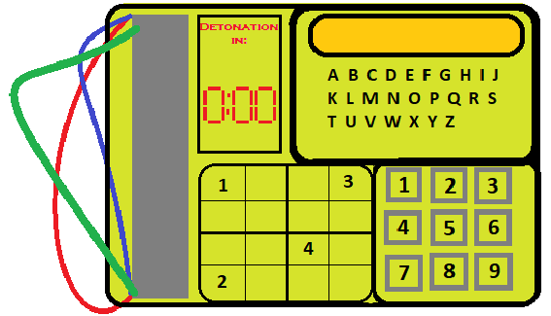The password is a random four-letter word.

E

A

B

C

D

Figure 4.1 shows the bomb, with Wires [A], Sudoku [B], number pad [C], keypad [D] and the Timer [E].

**4.3 Play Testing**

External play testing was carried out by Steve Yap. We received the following feedback:

“In the defuser task, the players may not know where the defuser is.”

“In task three, the sudoku may be too long, however it would be possible.

“State how long the players have until the bomb detonates in the How to Play manual.”

In response to Steve’s first point, the bomb design would have to have a diffuser added to this, however there was not enough time to do this. It was felt that Steve was correct that the sudoku could take too long, and as a result we increased the bomb timer from 3 minutes to 4 minutes so that it was more forgiving with the sudoku, without the game becoming too easy. The How to Play manual was also updated to include the time limit that the players must work with.

**4.4 Working in a Team**

As a group, working in a team was beneficial as everyone could add to or evolve others’ ideas. It also meant that while one team member was sorting out external play testing, the rest could focus on finishing the presentation, and making sure all the slides are clear and concise.

**Team Members**

Jaime Smith

Reece Taylor

Akash Sroay

Rowan Noble

**External Play Testing**

Steve Yap